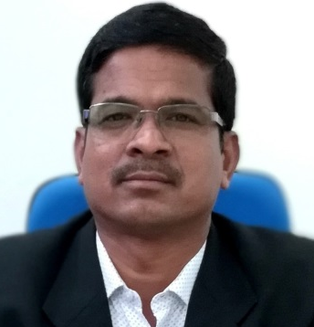
Brief Info.: Dr. Kamal Singh is Associate Professor in the Department of Civil Engineering, Maulana Azad National Institute of Technology, Bhopal (India). He obtained B.E. (Civil), M.Tech. (Civil) and Ph.D. (Civil) degrees from Maulana Azad National Institute of Technology, Bhopal. Dr. Kamal Singh has published more than 54 research papers in peer reviewed International Journals and Conferences of repute in geotechnical and transportation engineering areas. He has more than 25 years of experience which includes teaching, research, consultancy and administration. He has been teaching UG/PG level subjects like surveying, transportation, geotechnical, remote sensing, GIS etc. he has organized several conferences/workshop/short term training programs and delivered lectures at various programs.

Name | Dr. Kamal Singh
Designation | Associate Professor (Civil Engineering)
Existing Pay Scale :  Pay Level 13 A2 with AGP 9500/- | Existing Basic Pay Rs. 1,57,100/-  (Pay Level 13 A2 in 7th Pay General)
Address  Phone  E-mail | 4/9, MANIT Campus, Bhopal, M.P. India-462003  Phone: 0755-4051220(O), 0755-4052409(R), Mobile: 09425028146  singhk@manit.ac.in
Date of Birth | 08/04/1973
Educational Qualification | Ph.D. (Civil Engineering), M.Tech. (Geotech.), B.Tech. (Civil Engg.)  (MANIT Bhopal)
Experience | >25 Years
Specialization | Transportation Engineering, Geotechnical Engineering
Research Publications | - International Journals - 07  - National Conference. - 07  - International Conferences. -40 Total Published Papers - 54
Member of professional bodies | - Associate of Institution of Engineers India (A-527328-6)  - Life member of the ISTE (LM-32177)  - Life Member of Institution of Urban Transport (IUT) India  - Life member of The Indian Science Congress Association ((L27538)  - Life Member of Indian Road Congress (IRC) (eLM-100014)  - Life Member of Transportation Research Group of India (TRG), LM-20156  - Life Member of Indian Society of Remote Sensing (ISRS), L-5628  - Life Member of Indian Geotechnical Society (IGS), LM-4919  - Fellow Member of World Researchers Association (FM/2021/005)
Country Visited | 01 (Spain)
Number of P.G./M.Tech Projects Guided | More than 39
STTP Courses Organized | 7
International Conferences Organized | 3
Project/ Consultancy undertaken | Involved in providing testing and consultancy services in the area of Civil Engineering/ Transportation Engg. to various Govt. &Non Govt Organizations
Administrative work done | Sr. Warden, Warden, Departmental Exam Coordinator, Member UG Admission Committee, Institute Assistant Public Relation Officer, Member ARC, EE (Civil), EE (Electrical), Member DRPC, Coordinator DUPC, Chairman Green Cell MANIT, Member Security Advisory Committee, HOD Chemical Engineering (April 08th to October 08th 2020), Coordinator HEFA Projects (from 24.1.2019 to 24 April 2020), Member House Allotment Committee
Any other information | Interaction with State PSC and UPSC as subject experts, Interview committees.

